

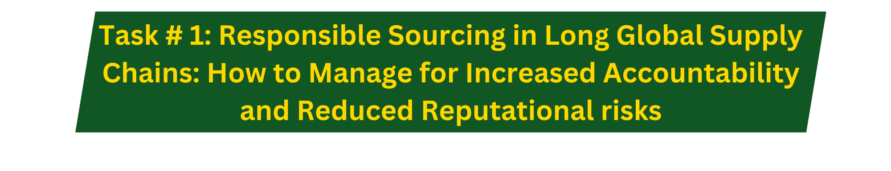

Pick any of these examples, or any other incident with similar issues, and comment on why for profit companies should worry about them. What are your recommendations for “responsible balanced approach” supply chain practices to put in place for a particular company or industry you would like to apply these concepts?
In class this weekend we discussed several cases of responsible sourcing in global supply chains with several different cases. We discussed the Rana Plaza disaster, suicides at Foxconn, and several others. These topics were very well timed for me as I have been reading about the supply chain of recycling automotive batteries as reported by the New York Times: https://www.nytimes.com/interactive/2025/11/18/world/africa/lead-poisoning-car-battery.html. This article touched a cord for me for several reasons and our conversations this weekend gave me an excellent snapshot of the costs businesses will face if they don’t act to prevent



